**2018-19 Reclassified Student Proficiency Rates in Reading and Math**

**Axis labels: 0%, 20%, 40%, 60%, 80%, 100%**

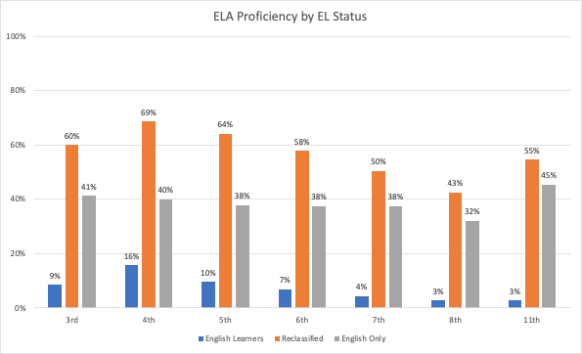

*Source: California Department of Education. (February 2021). 2018-19 California Assessment of Student Performance and Progress Test Results*

English Learner = blue

Reclassified Fluent English Proficient = orange

English only = gray

**English Language Arts Proficiency by Language Status**

|  |  |
| --- | --- |
| **3rd** | **9%, 60%, 41%** |
| **4th** | **16%, 69%, 40%** |
| **5th** | **10%, 64%, 38%** |
| **6th** | **7%, 58%, 38%** |
| **7th** | **4%, 50%, 38%** |
| **8th** | **3%, 43%, 32%** |
| **11th** | **3%, 55%, 45%** |

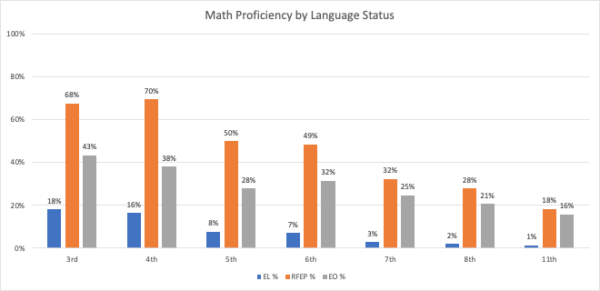

*Source: California Department of Education. (February 2021). 2018-19 California Assessment of Student Performance and Progress Test Results.*

**Math Proficiency by Language Status**

|  |  |
| --- | --- |
| **3rd** | **18%, 68%, 43%** |
| **4th** | **16%, 70%, 38%** |
| **5th** | **8%, 50%, 28%** |
| **6th** | **7%, 49%, 32%** |
| **7th** | **3%, 32%, 25%** |
| **8th** | **2%, 28%, 21%** |
| **11th** | **1%, 18%, 16%** |

**Takeaways**

When we look at English Language Arts (ELA) and math proficiency rates across Fresno public schools we see that students reclassified as Fluent English Proficient (RFEP) outperform their English-only peers across all grade levels, sometimes by as much as 30 percentage points.

Students who haven’t reclassified continue to lag far behind their reclassified and English-only peers. In most grades, fewer than 1 in 10 ELs are meeting ELA or math standards.

**Why are we using data from the 2018-19 school year?**

Fresno public schools first closed in March of 2020 in response to the coronavirus pandemic. The decision to waive state assessments was made shortly after these closures. Without 2019-20 state assessment data, the most current data available to us comes from the state assessments taken during the 2018-19 school year